# CHAPTER 1 INTRODUCTION

1. **Introduction**

The Online Fitness Tracker is an advanced web-based application tailored to address the needs of individuals striving for a healthier lifestyle. In today’s fast-paced world, maintaining fitness has become a challenge, and existing tools often fall short of providing a comprehensive, user-friendly experience. This project bridges the gap by combining powerful tracking capabilities with an intuitive interface, making fitness management accessible to everyone—from beginners to seasoned athletes.

The system goes beyond simple activity logging to offer a holistic approach to fitness tracking. It integrates features like nutritional data management, personalized goal setting, and progress visualization to empower users to take control of their fitness journeys. Whether someone wants to lose weight, gain muscle, or simply maintain a healthy routine, the Online Fitness Tracker provides the tools and insights needed to succeed.

* **1.1 Existing System**

The existing systems for fitness tracking are typically limited in functionality and scope. Most

of these systems are either standalone applications or basic web platforms that fail to

provide comprehensive fitness tracking features. They often lack personalized

goal-setting, detailed progress tracking, or a robust interface for managing user activities

and nutrition. Additionally, many existing platforms are either overly complex for average

users or too simplistic to meet the needs of fitness enthusiasts.

* + - **1.2 Need of the System**

The growing emphasis on health and wellness has created a demand for a more sophisticated and user-friendly fitness tracking system. The current gap in the market calls for a platform that can seamlessly integrate with users’ routines and provide actionable insights into their fitness journeys. This system should cater to both beginners and experienced fitness enthusiasts by offering personalized plans, progress visualization, and tracking capabilities. By addressing these needs, the proposed system will empower users to achieve their fitness goals efficiently and effectively

* + - **1.3 Overview of the Project**

The Online Fitness Tracker is designed to be a comprehensive solution for tracking fitness activities, managing nutritional data, and setting personalized fitness goals. Built with modern web technologies, this platform offers an intuitive user interface and robust backend functionality. Key features include:

* **Activity Tracking**: Monitor daily workouts and physical activities.
* **Nutritional Insights**: Log meals and track calorie intake.
* **Goal Setting**: Set and achieve fitness milestones.
* **Progress Visualization**: View detailed analytics and reports on progress over time.

# CHAPTER 2

**LITERATURE SURVEY**

1. **LITERATURE SURVEY**

The Literature Survey involves an in-depth analysis of existing fitness tracking systems and related technologies. This survey evaluates the features, limitations, and performance of various platforms to identify gaps and opportunities for improvement. Key findings include:

1. **Lack of Integration**: Many existing systems focus on isolated features rather than offering an all-encompassing solution.
2. **User Experience Challenges**: Interfaces are either too complex for beginners or too limited for advanced users.
3. **Limited Personalization**: Most platforms fail to adapt to individual user needs or provide meaningful insights.

These observations have been instrumental in shaping the development of the Online Fitness Tracker, ensuring it addresses shortcomings and meets user expectations.

* 1. **Feasibility Study**

The feasibility study examines the practicality of implementing the Online Fitness Tracker by analyzing technical, economic, and operational aspects.

* 1. **Technical Feasibility**

The Online Fitness Tracker leverages a robust technology stack, including modern web development frameworks and scalable cloud infrastructure. The system’s architecture ensures seamless performance, secure data management, and compatibility across devices. With the use of proven tools and technologies, the project is technically feasible and ready for deployment.

* 1. **Economic Feasibility**

The project is designed to be cost-effective, with a focus on delivering high value to users without incurring excessive expenses. The scalable infrastructure minimizes overhead costs, and the potential for subscription-based revenue models ensures sustainability. The balance between investment and projected benefits makes the project economically viable.

* 1. **Operational Feasibility**

From a user perspective, the Online Fitness Tracker is intuitive and easy to adopt. Its design prioritizes user engagement and retention, making it a practical solution for diverse audiences. The platform’s ability to integrate seamlessly into users’ routines ensures operational success and widespread acceptance.

# CHAPTER 3 REQUIREMENT

## SOFTWARE REQUIREMENT:

1. **Operating System**:

* Cross-platform compatibility, including Windows, macOS, and Linux.

1. **Web Server**:

* Node.js server for handling backend operations.

1. **Technology Stack**:

* MERN (MongoDB, Express.js, React.js, Node.js) for efficient development and performance.

1. **Version Control**:

* Git for managing source code and collaborative development.

## HARDWARE REQUIREMENT:

1. **Server**:

* Cloud-based server with scalable infrastructure to handle user traffic.

1. **Storage**:

* Minimum of 100 GB for storing user data, logs, and application resources.

1. **Memory (RAM)**:

* At least 8 GB for optimal server-side and client-side performance.

1. **Processor**:

* Multi-core processor (e.g., Intel Core i5 or equivalent) for handling concurrent operations efficiently.

.

# CHAPTER 4 DESIGN

* + - 1. **Database Table design(Applicable to Project)**

1. **User Table :**

|  |  |  |
| --- | --- | --- |
| **Field Name** | **Data Type** | **Description** |
| _id | Object ID | Unique identifier for each user |
| Name | String | Full name of the user |
| Email | String (Unique) | Email address of the user |
| Image | String | URL of the user’s profile picture |
| Password | String | Encrypted user passsword |
| Age | Number | Age of the user |
| Created At | Date | Timestamp when the record was created |
| Updated At | Date | Timestamp when the record was last updated |



1. **Workout Table**

|  |  |  |
| --- | --- | --- |
| **Field Name** | **Data Type** | **Description** |
| _id | Object ID | Unique identifier for each workout. |
| User | Object ID | References the user performing the workout. |
| Category | String | Category of the workout (e.g., cardio, strength). |
| Workout Name | String (Unique) | Name of the workout. |
| Sets | Number | Number of sets performed. |
| Reps | Number | Number of repetitions per set. |
| Weight | Number | Weight used during the workout (if applicable). |
| Duration | Number | Duration of the workout in minutes. |
| Calories Burned | Number | Estimated calories burned during the workout. |
| Data | Number | Date the workout was performed. |
| Created At | Date | Timestamp when the record was created. |
| Update At | Date | Timestamp when the record was last updated. |

* + - 1. **Software Engineering Diagrams (Applicable for Project)**
         1. **ER Diagram :**

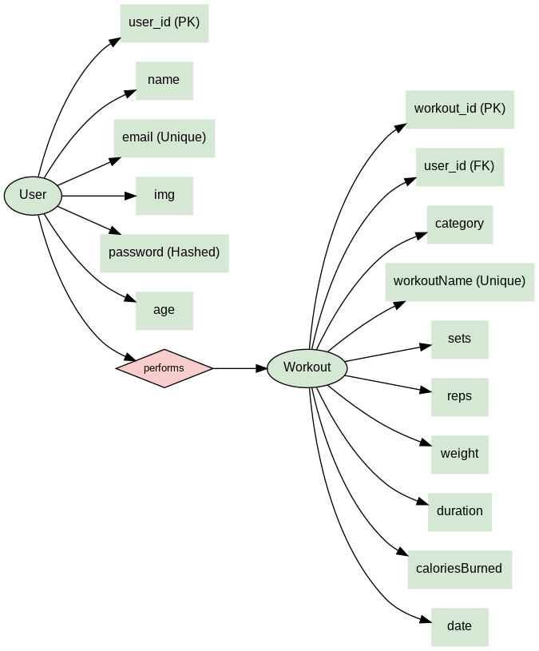

* + - 1. **UML Diagrams**
         1. **Class Diagram**

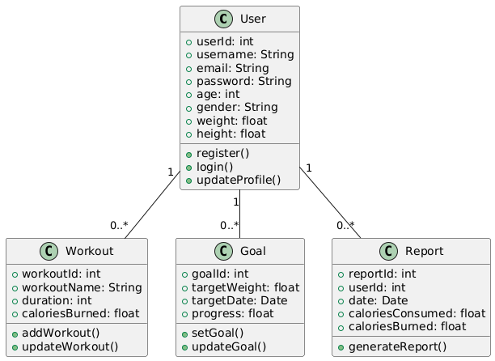

* + - * 1. **Use Case Diagram**

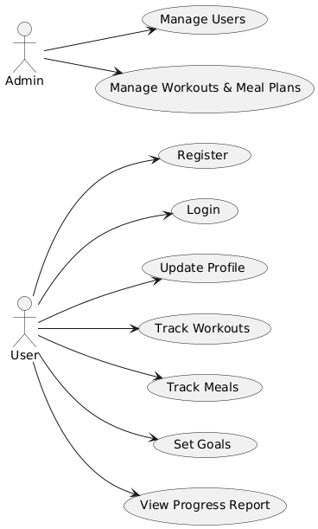

* + - * 1. **Activity Diagram For User**

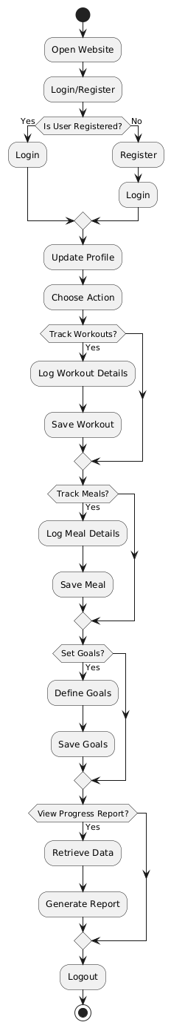

* + - * 1. **Sequence diagram For User**

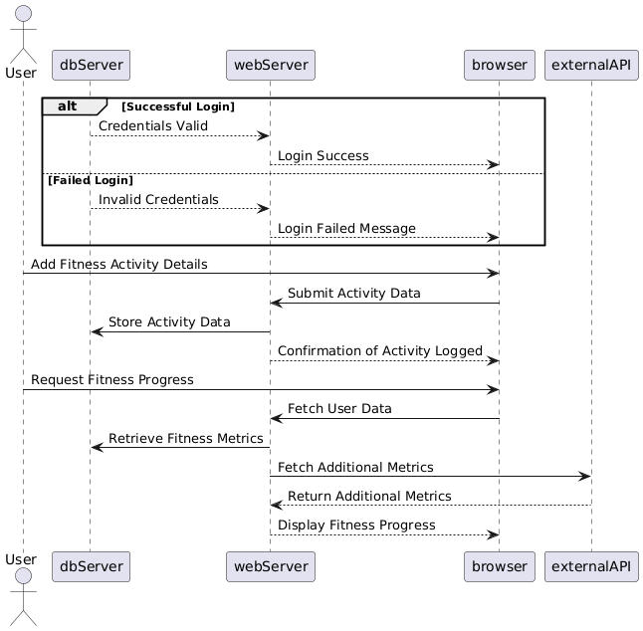

* + - * 1. **Deployment Diagram**

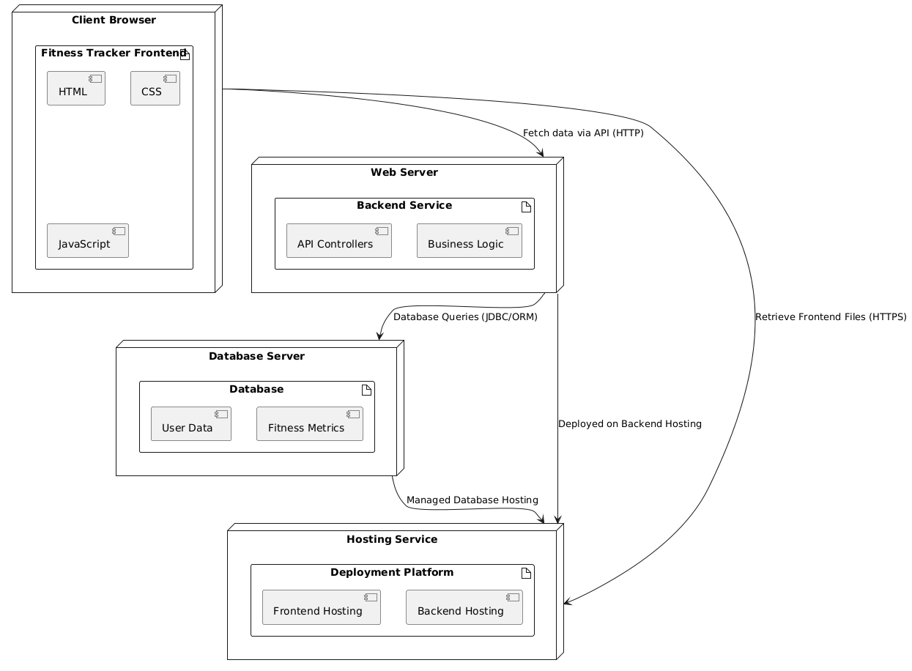

# CHAPTER 5 CODING

1. **Backend (PHP):**

This section will focus on the backend development, detailing the technologies, architecture, and API endpoints that power the functionality of the website.

#### 5.2.1 Technologies Used

* **Node.js**: Runtime environment for server-side JavaScript.
* **Express.js**: A web framework for building RESTful APIs.
* **MongoDB**: NoSQL database for storing user data, workouts, meals, and goals.
* **Mongoose**: ODM library for MongoDB, enabling schema-based modeling.
* **JWT (JSON Web Tokens)**: For secure user authentication.
* **bcrypt.js**: For hashing passwords.

#### 5.2.2 API Endpoints

1. **User Management**:
   * POST /api/signup: Register a new user.
   * POST /api/signin: Authenticate a user and return a JWT.
2. **Workouts**:
   * POST /api/workout: Log a new workout.
   * GET /api/workout: Retrieve the user's workout history.
3. **Progress Reports**:
   * GET /api/dashboard: Generate a progress report based on workouts and meals.
4. **Frontend (HTML, CSS, JavaScript):**

This section will describe the implementation of the user interface for the fitness tracking website, detailing the technologies, frameworks, and libraries used to build an interactive and responsive user experience.

#### 51.1 Technologies Used

* **HTML5**: For structuring the content of the web pages.
* **CSS3**: For styling and layout, enhanced by **TailwindCSS** and **DaisyUI** for faster development.
* **JavaScript**: To enable dynamic and interactive features.
* **React.js**: A JavaScript library for building user interfaces with reusable components.
* **Axios**: For making API calls to the backend.

#### 5.1.2 Key Features of the Frontend

1. **User Registration and Login Pages**:
   * Forms for creating an account and logging in.
   * Input validation and error handling.
2. **Dashboard**:
   * Displays user-specific data such as workout history, meal logs, and progress reports.
3. **Workout and Meal Tracking**:
   * Intuitive forms for users to log their activities.
   * Integration with charts for visualizing progress.
4. **Responsive Design**:
   * Ensures the application works seamlessly on various devices (mobile, tablet, desktop).
5. **Reusable Components**:
   * Modular design for consistency and maintainability

# CHAPTER 6 TESTING

### Importance of Testing

Testing is a critical phase in the software development lifecycle, ensuring that the developed application functions as intended and meets the requirements of the end-users. Without rigorous testing, even the most well-designed software can fail due to unforeseen bugs or edge cases, leading to a poor user experience and potential financial or reputational losses. Testing helps in identifying defects early in the development process, reducing the cost of fixing them later.

For a fitness tracking website, testing ensures that all features, such as workout tracking, meal logging, and progress reporting, function seamlessly. As users depend on accurate data for their fitness journey, even minor errors in functionality or calculations can result in a loss of trust in the application. Testing ensures the reliability and accuracy of the application, building user confidence in its performance.

Moreover, testing improves software quality by verifying its compliance with functional and non-functional requirements. This includes ensuring responsiveness on different devices, compatibility with multiple browsers, and secure handling of sensitive user data. Testing also helps maintain consistent performance under various load conditions, ensuring a smooth experience for users even during high-traffic periods.

Additionally, testing enhances the maintainability and scalability of the application. By uncovering flaws in the code or design, it enables developers to fix issues and optimize the application. This, in turn, makes future updates or feature additions easier to implement without introducing new defects.

Lastly, testing contributes to risk mitigation. It helps in identifying and addressing vulnerabilities that could lead to security breaches, ensuring the safety of sensitive user data like login credentials and personal information. For a fitness tracking application, this aspect is especially vital as users expect their privacy to be safeguarded.

In summary, testing is not merely a phase but an ongoing process that ensures the overall quality, reliability, and security of the application. By investing in thorough testing, developers can deliver a robust and user-friendly product that meets the expectations of its audience

### Types of Testing

For this fitness tracking website, various types of testing were performed to ensure the application’s functionality, reliability, and security. Each type of testing addresses a specific aspect of the application and ensures its readiness for deployment.

* + 1. **Unit Testing:**  
        Unit testing was performed to verify the functionality of individual components, such as the login form, workout tracker, and meal logger. Each function and method was tested in isolation to ensure they behave as expected. For example, tests were conducted to check if the "calculate calories burned" feature returned accurate results for different inputs.
    2. **Integration Testing:**  
       Integration testing focused on ensuring seamless communication between different modules. For instance, it was tested whether data entered in the workout tracker was accurately reflected in the progress reports and whether the login system properly interacted with the user authentication module.
    3. **Functional Testing:**  
       Functional testing ensured that the website met the functional requirements defined during the design phase. This included testing critical user journeys like registration, login, logging workouts and meals, and viewing progress reports. Each feature was tested for accuracy and usability.
    4. **Usability Testing:**  
       To provide a positive user experience, usability testing was conducted. This involved testing the user interface for intuitiveness and responsiveness. Users were involved in providing feedback on the design, ensuring it was easy to navigate and operate across various devices and screen sizes.
    5. **Performance Testing:**  
       Performance testing evaluated how the application performed under different load conditions. Tests were conducted to determine if the website could handle multiple users simultaneously logging their workouts or accessing reports without any lag or crashes.
    6. **Security Testing:**  
       Given the sensitive nature of user data, security testing was crucial. This involved testing for vulnerabilities like SQL injection, cross-site scripting (XSS), and weak password policies. The implementation of secure authentication and data encryption mechanisms was also verified.
    7. **Regression Testing:**  
       As the project evolved with new features and updates, regression testing ensured that the existing functionality remained intact. This type of testing was performed after every update to confirm that changes did not introduce new bugs or break the application.

By combining these testing types, the fitness tracking website was rigorously validated to ensure it meets user expectations and industry standards. Each testing phase contributed to a robust, reliable, and secure application.

1. **Test cases**
2. **Module: User Registration**

|  |  |  |  |  |  |
| --- | --- | --- | --- | --- | --- |
| 4 | TC-04 | User Interfac e | Check Keeping Password | 1. Enter valid username 2. Do not enter password 3. Click on Login Button | User should not log in and should show proper erro message |
| 5 | TC-05 | User Login | Check when pass correctemailand password | 1. Enter valid username 2. Enter valid password3.Click on Login Button | User should log in |
| 6 | TC-06 | User Login | Check if the password isentered in encrypted | 1. Enter valid username 2. Enter password. 3. Click on Login Button | Password is entered in encrypted form |

# CHAPTER 7 RESULT

**7.1 Input Output screens**

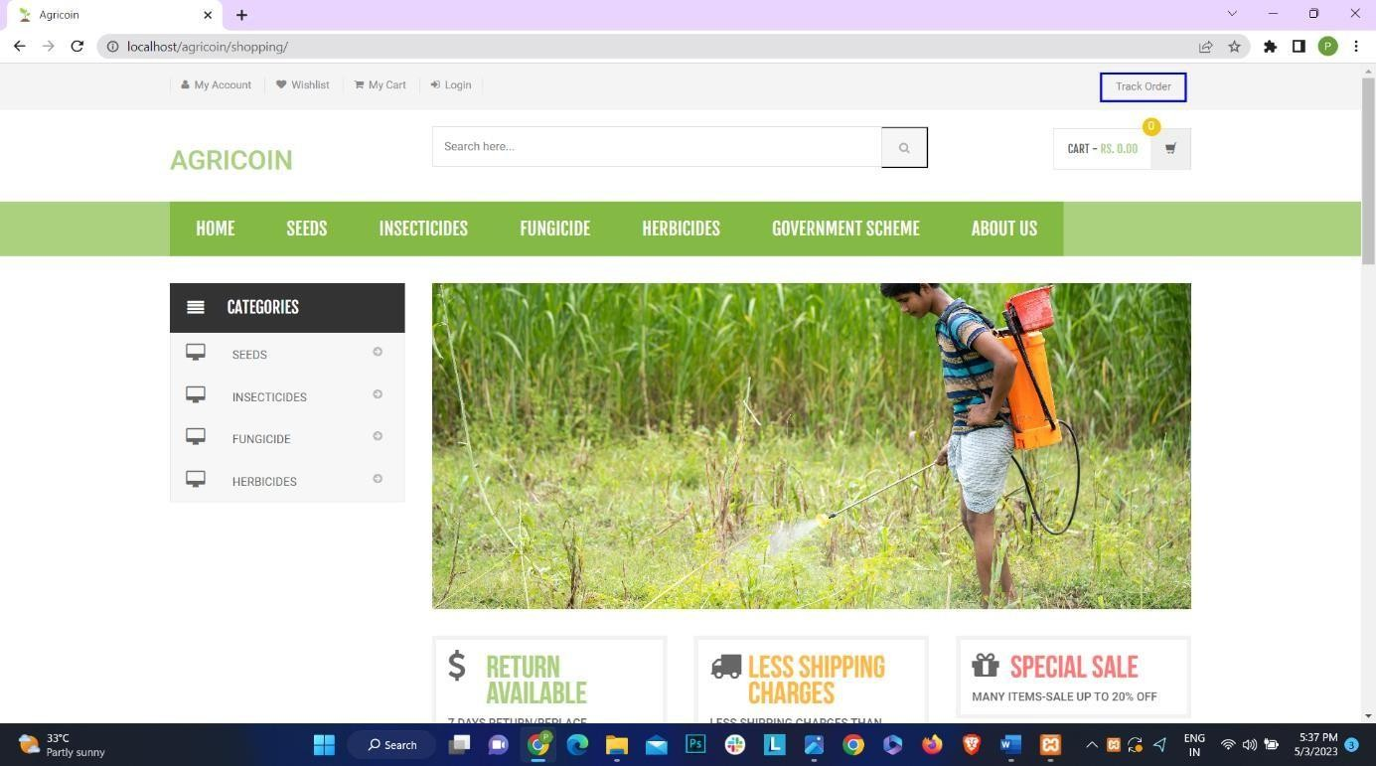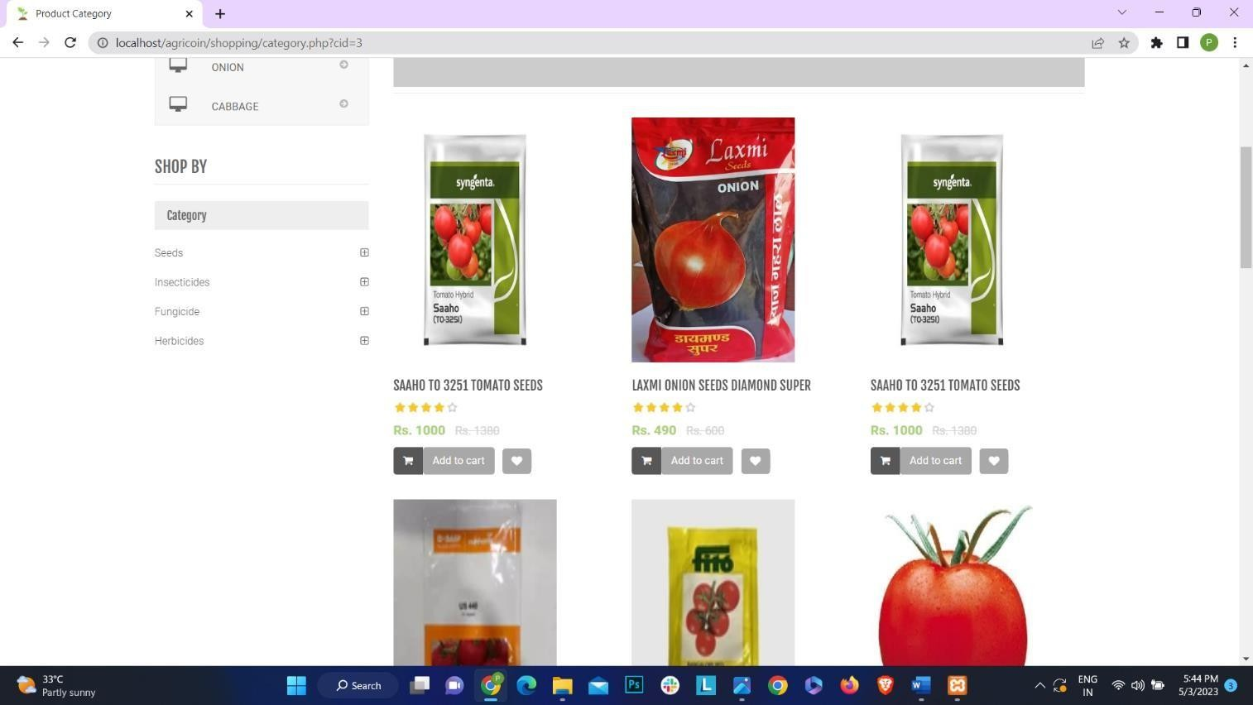

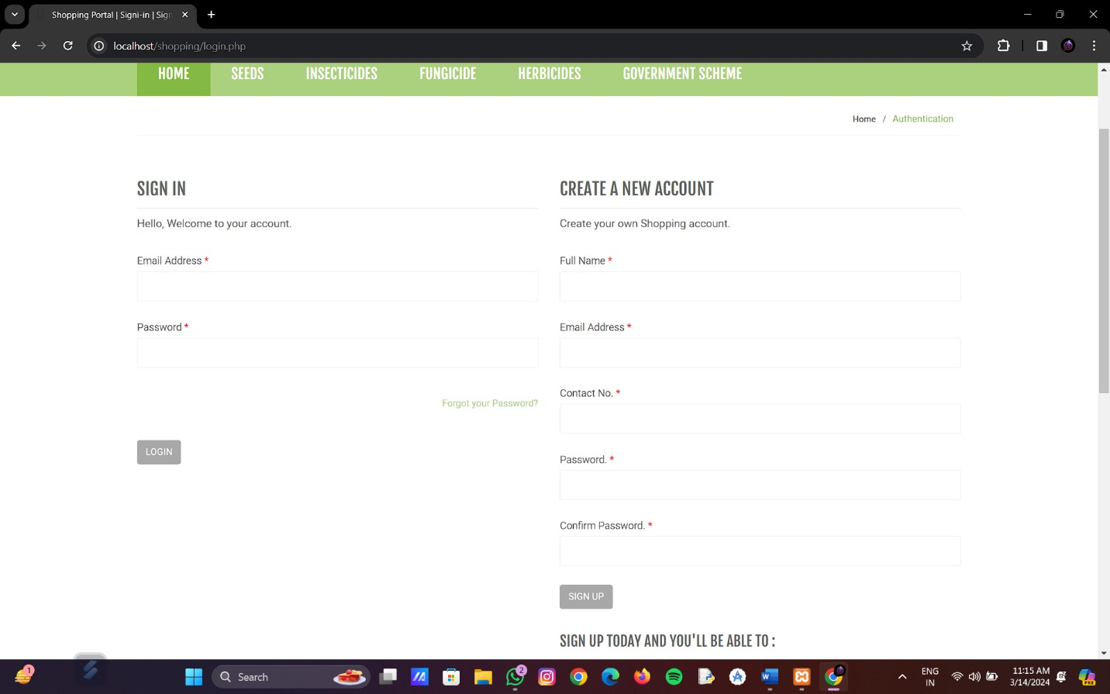

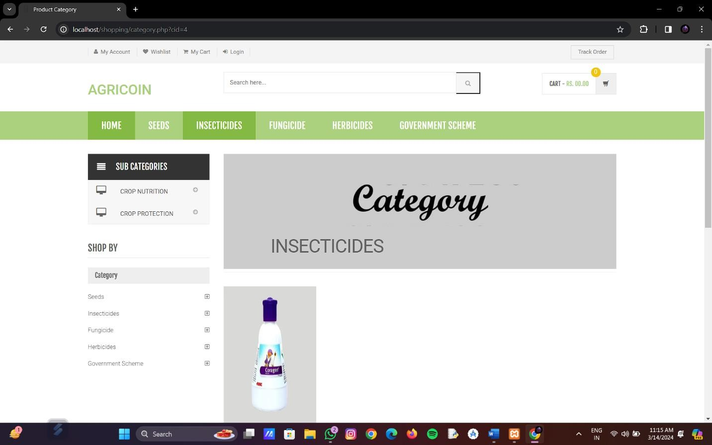

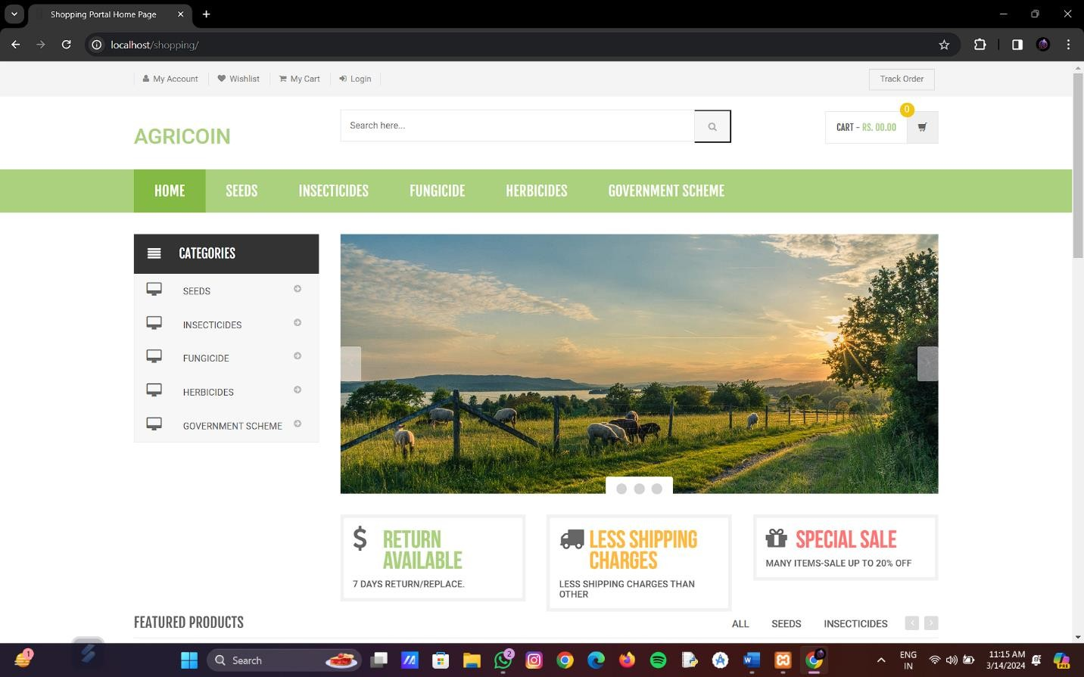

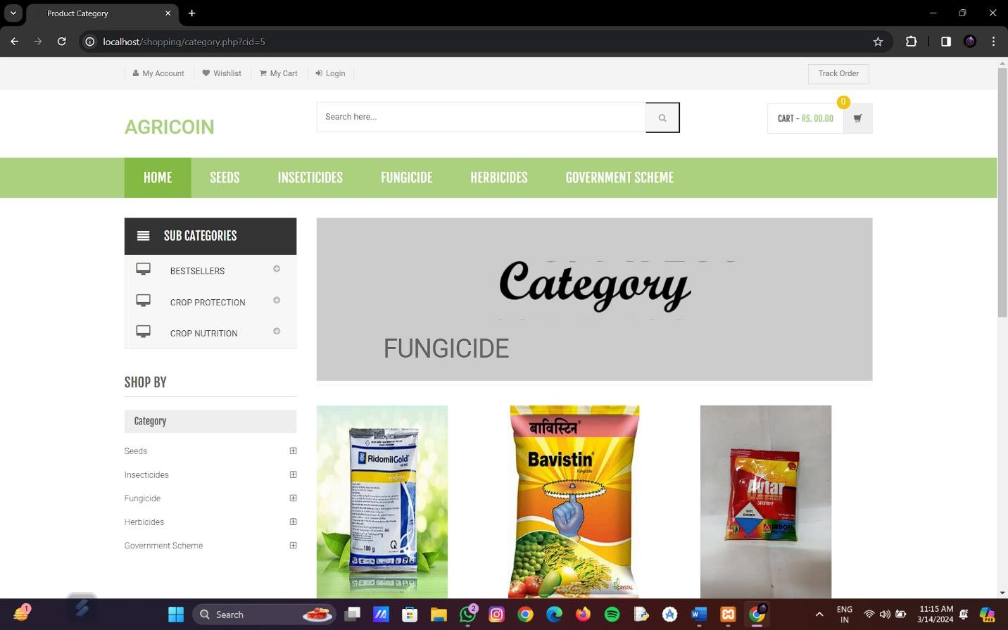

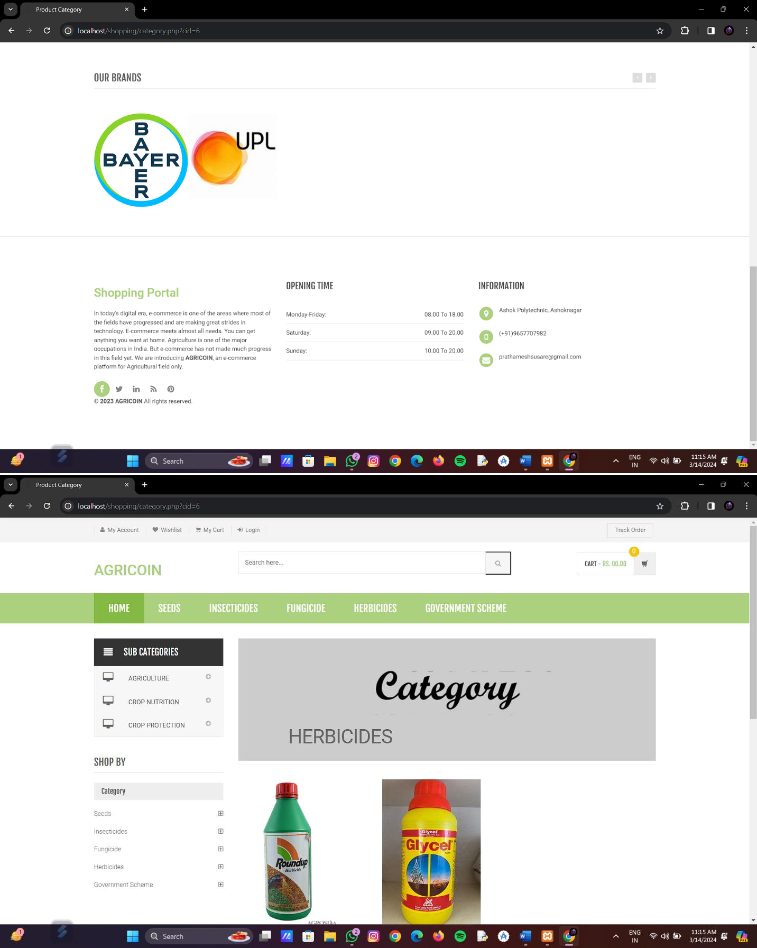

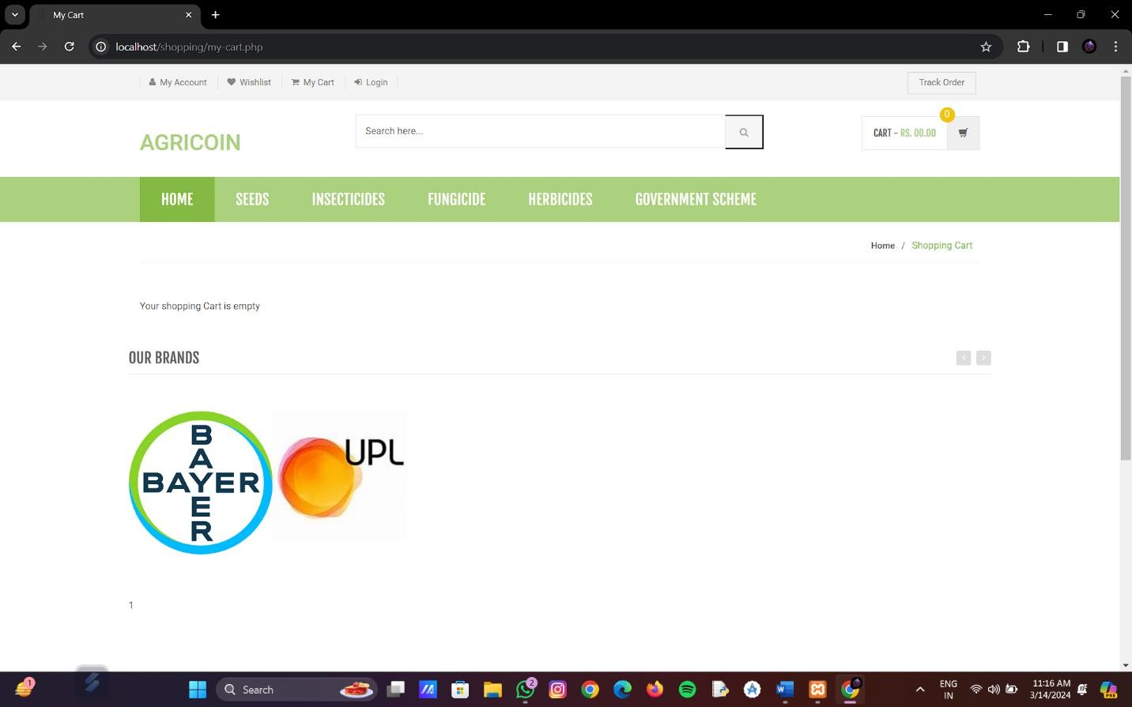

Admin

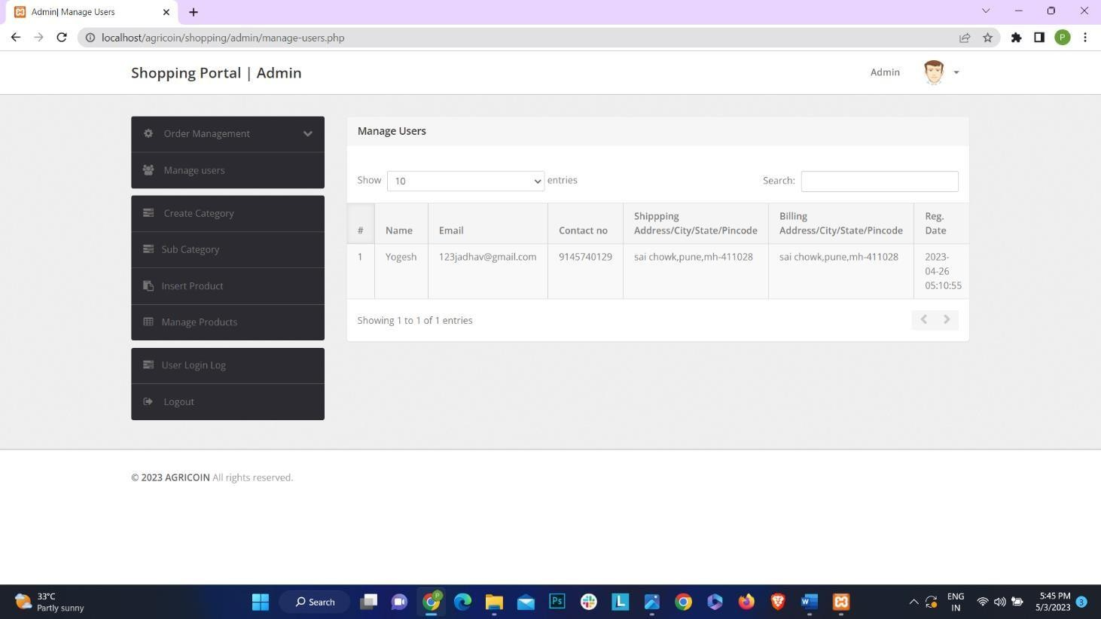

# CHAPTER 8 FUTURE SCOPE

* 1. **AI-driven Product Recommendation:** Implementing artificial intelligence algorithms to recommend agricultural products based on factors such as crop type, soil quality, weather conditions, and historical purchase data. This would enhance user experience and increase sales by offering personalized recommendations.
  2. **Real-time Crop Monitoring:** Integration of IoT devices and sensors in farmlands to monitor crop health and environmental conditions in real-time. This includes tracking soil moisture levels, temperature, and pest infestations, allowing farmers to take timely actions to protect their crops.
  3. **Biometric Authentication for Farmers:** Implementing biometric authentication systems for farmers accessing the Agricoin platform to ensure secure transactions and prevent unauthorized access to sensitive data. Biometric authentication methods such as fingerprint or facial recognition can be utilized for this purpose.
  4. **Mobile Application Interface:** Developing a mobile application for farmers to access Agricoin's platform on-the-go. The app can provide features such as browsing products, placing orders, tracking shipments, and receiving notifications about discounts or promotions.
  5. **Accessibility Features:** Ensuring the Agricoin platform is accessible to farmers with disabilities by incorporating features such as voice command navigation, adjustable font sizes, and compatibility with screen readers. This promotes inclusivity and ensures all farmers can utilize the platform effectively.
  6. **Predictive Analytics for Crop Management:** Utilizing data analytics and machine learning techniques to provide predictive insights for crop management. This includes predicting optimal planting times, estimating yield potential, and identifying potential risks such as disease outbreaks or adverse weather conditions.
  7. **Blockchain-based Supply Chain Traceability:** Implementing blockchain technology to create a transparent and tamper-proof supply chain for agricultural products. Farmers can track the journey of their produce from farm to consumer, ensuring authenticity and quality assurance.
  8. **Integration with Agricultural Management Software:** Seamless integration with existing agricultural management software used by farmers to manage their farms. This includes synchronizing data such as crop inventory, harvest schedules, and financial records, reducing manual entry and streamlining farm operations.

By incorporating these advanced features, Agricoin can revolutionize the agricultural industry by providing farmers with access to cutting-edge technology and tools to optimize their farming practices and enhance productivity.

# CHAPTER 9 CONCLUSION

The development of Agricoin, an online agricultural shop website, represents a significant stride towards modernizing the agricultural industry and facilitating efficient transactions between farmers and consumers. Through the integration of cutting-edge technologies such as AI-driven product recommendations, real-time crop monitoring, and blockchain-based supply chain traceability, we have aimed to revolutionize the way agricultural products are bought and sold.

By leveraging predictive analytics, accessibility features, and biometric authentication, Agricoin strives to enhance user experience, ensure security, and promote inclusivity within the agricultural community. The platform's mobile application interface offers farmers convenient access to a wide range of agricultural products, allowing them to browse, purchase, and track their orders with ease. Furthermore, the feedback mechanism enables continuous improvement based on user input, ensuring that Agricoin remains responsive to the evolving needs of its users.

As we conclude this endeavor, we recognize the transformative potential of Agricoin to empower farmers, streamline agricultural transactions, and foster sustainable practices in farming. Our collaborative approach, involving stakeholders such as farmers, suppliers, and agricultural

experts, has been instrumental in shaping Agricoin into a user-centric platform that meets the diverse needs of the agricultural community. Together, we are paving the way for a more efficient, transparent, and resilient agricultural ecosystem

# CHAPTER 10 BIBLIOGRAPY

With the help of online website and our project guide and also a with help of our group members we have completed this project

* + 1. **For PHP**
       - <https://www.w3schools.com/php/default.asp>
       - <https://www.sitepoint.com/php/>
       - <https://www.php.net/>
    2. **For MySQL**
       - <https://www.mysql.com/>
       - [http://www.mysqltutorial.org](http://www.mysqltutorial.org/)
    3. **For XAMPP**
       - <https://www.apachefriends.org/download.com>